Module 8

Assignment 8.2
Course: CSD402-340A Java for Programmers
Prepared By: Mirach Erkol
Date of Report: 2/21/2025

https://github.com/Mikey5007/CSD340.git

8.2 Assignment: Build a Webpage Exercise
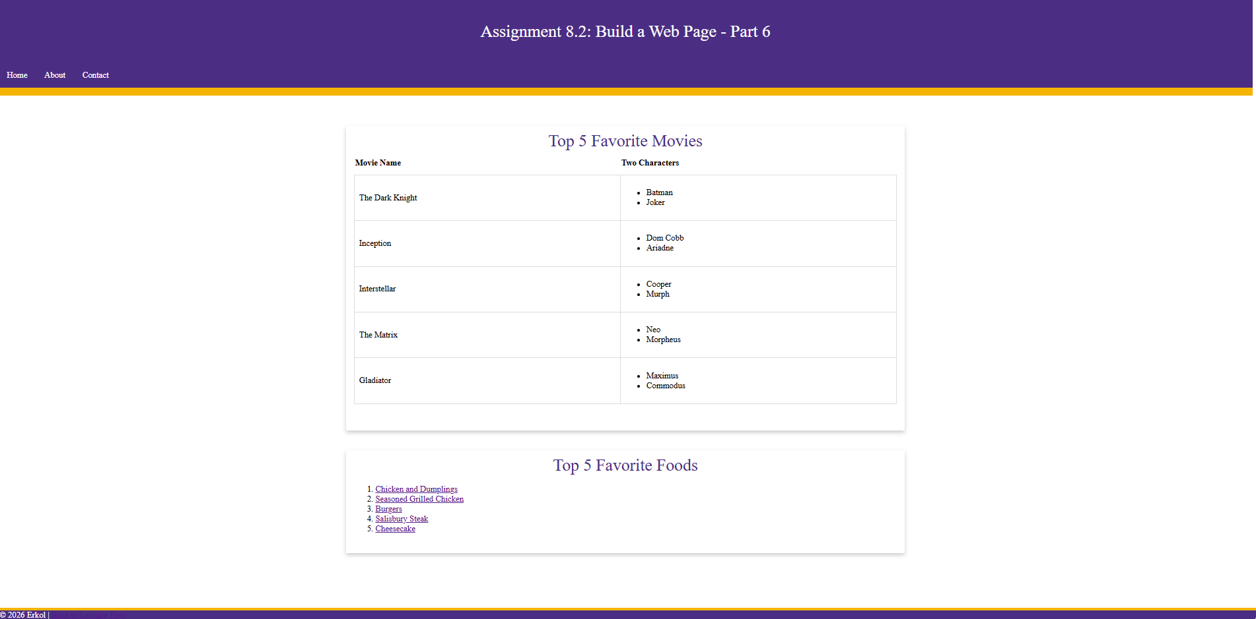
8.2 Assignment: Homepage with Assignment 6.2 Link
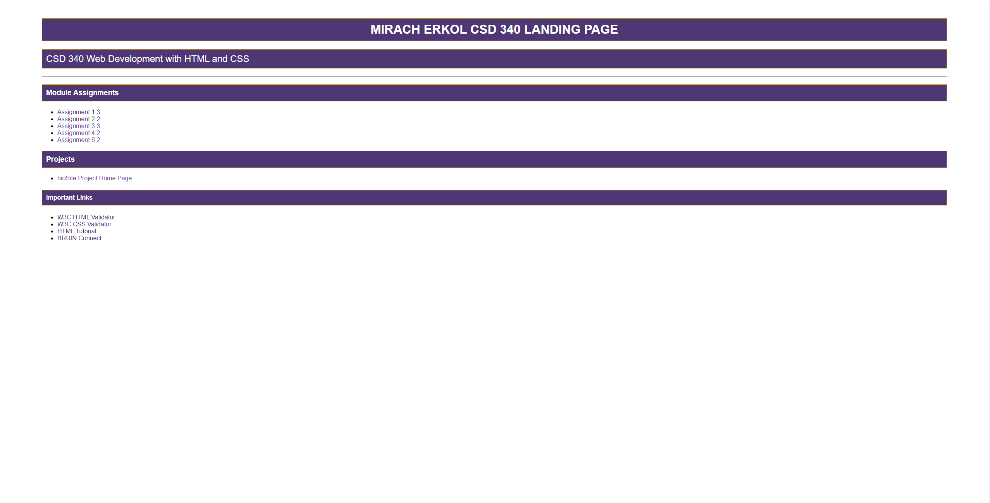

References:

https://github.com/Mikey5007/CSD340.git

